

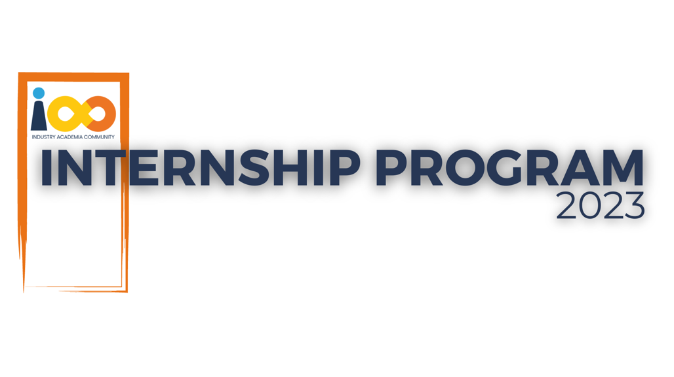

PROJECT REPORT

Web Development  
  
Collegeopedia

|  |  |  |  |
| --- | --- | --- | --- |
| **Created By:** | Prasad Pathare | **Approved By:** | Jonathan Dabre |
| **Created On:** | 20-09-2023 | **Approved On:** | 30-09-2023 |

Page left blank intentionally

**INDEX**

**1** **PROJECT DETAILS** 2

**2** **SUMMARY** 2

**3** **INTRODUCTION** 2

3.1 Background 2

3.2 Stakeholders 2

3.3 Objectives 2

**4** **METHODOLOGY** 2

4.1 Considerations & Assumption 3

4.2 Approach 3

4.3 Activities 3

**5** **TARGETTED V/S ACHIEVED OUTPUT** 3

**6** **CONCLUSION** 3

**7** **APPENDICES** 4

7.1 Appendix A – Title 4

# **PROJECT DETAILS**

|  |  |  |  |
| --- | --- | --- | --- |
| **Project Name** | Collegeopedia | | |
| **Project Sponsor** |  | | |
| **Project Manager** | Jonathan Dabre | | |
| **Start Date** | 31-07-2023 | **Completion Date** | 30-09-2023 |

# **SUMMARY**

This is a web-oriented application allows students to access the whole information about the colleges, Universities and facilities etc. This application provides a virtual tour of any Campus. Here we will get the latest information about the various colleges and the courses they are offering. This generic application designed for assisting the students regarding information on the courses, subjects, classes.

**INTRODUCTION**

## Background

Today in colleges students have vast options of colleges to choose for their further studies. This a tedious task. Referring to all these records and updating is needed. There is a chance for more manual errors.

**Problems in existing system:**

* It was limited to a single system.
* It was less user-friendly.
* It has a lot of manual work (Manual system does not mean that we are working with pen and paper, it also includes working on spread sheets and other simple software's)
* It requires more no of employees need to work.
* It was time consuming process.
* The present system was very less secure.

**Solution to these problems:**

The development of the new system contains the following activities, which try to automate the entire process keeping in view of the database integration approach.

* User friendliness is provided in the application with various controls.
* The system makes the overall management much easier and flexible.
* It can be accessed over the Internet.
* Various students and colleges have been used to provide file upload.
* There is no risk of data mismanagement at any level while the project development is under process.

## Stakeholders

## Objectives

Building a web application that would have in the backend the database of all the IT & Management colleges in India along with other colleges that offer at least one IT or Management course.

The web application built with the tech stack comprising HTML, CSS, JavaScript for both front-end and back- end development, and a SQL-based database will be compatible with various operating systems, including Linux, macOS, and Windows, providing flexibility in choosing the most suitable development and deployment environment.

To handle back-end development and create API endpoints, JavaScript will be used. For the database, a SQL- based system will be employed to store and manage the college/university information.

## 

# **METHODOLOGY**

These conventions are all about the positions of line breaks, how many characters should go on a line, and everything in between.

## Considerations & Assumption

## The website may experience technical issues, such as downtime or slow performance, impacting user experience. Users possess basic computer skills required to navigate and utilize the website.

## Approach

## structural approach for a college portal involves organizing the portal's content and functionality to ensure that it serves the needs of students, Universities effectively.

## Activities

* Developed a detailed project plan with timelines and milestones.
* Created a budget, considering hardware, software, personnel, and other resources.
* Identified potential risks and create a risk management plan.
* Looked into the technical architecture and infrastructure requirements.
* Set quality standards and project acceptance criteria.

# **TARGETTED V/S ACHIEVED OUTPUT**

Targeted Output: Implementing robust security measures to protect student data and user accounts. Conduct regular security audits and share reports on security improvements.

Achieved Output: Implemented features such as college search adding new colleges as per user’s needs, to foster student interaction and engagement. Measure increased forum participation, and info addition

ensured the portal is accessible to all users, including those with disabilities.

# **CONCLUSION**

In conclusion, the college portal project has achieved significant milestones and improvements in enhancing student engagement, accessibility, and administrative efficiency. It has become an integral part of the college community, providing students with a centralized platform for information access.

As technology evolves, consider integrating emerging technologies such as AI and machine learning to enhance personalization, recommendation systems, and chatbot assistance.

Continuously improve the mobile experience by adopting progressive web app (PWA) technologies or dedicated mobile app development to stay up-to-date with mobile user expectations